Executive Summary Report
AnalystLab Africa Data Analytics Internship Program
Week 2: Business Analytics Case Study

Prepared by: Ahanonu Immanuel
Date: August 2026

Executive Summary
Global Superstore grew sales at a healthy pace between 2011 and 2014 from $2.26M to $4.30M, a 90% increase; and profit grew right alongside it, from $249K to $504K. On the surface this looks like a growth success story. But overall profit margin has been essentially flat at 11-12% for four straight years despite the scale gained, which means the business is not getting more efficient as it grows; it is simply doing more of the same mix of profitable and unprofitable business.
The analysis below finds that profitability is not a broad, structural problem; it is heavily concentrated in a few identifiable places: excessive discounting (especially above 20%), the Furniture category (particularly Tables, which lose money overall), and a handful of underperforming countries and the Southeast Asia region. These are fixable with targeted policy changes rather than a wholesale strategy overhaul.

Key findings, in order of financial impact:
- Growth is strong but margin is stagnant. Total Sales reached $12.6M (+51.5% YoY) and Total Profit reached $1.47M (+52.3% YoY), yet Profit Margin moved only from 11.5% to 11.6%. This shows that revenue growth is being driven largely by volume, not profitability.

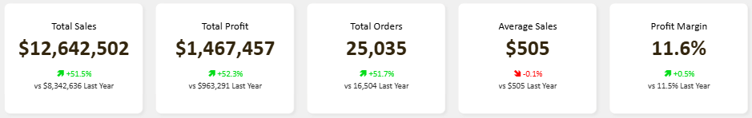

- Discounting above roughly 20% is actively destroying profit. Profit margin decays from +25.3% at 0% discount to -111.0% at discounts of 50%+, turning negative between the 11-20% and 21-30% bands. The business lost $848,886 to discounts over 20% this year which is up 50.9% from $562,543 the prior year.
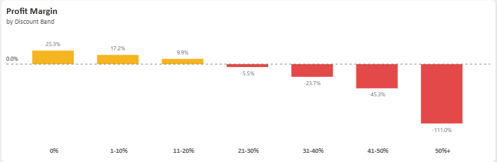

- Furniture is the weakest category, and Tables is a structural loss-maker. Furniture's margin is just 6.9%, versus 14.0% for Technology and 13.7% for Office Supplies. At the sub-category level, Tables lost -$64,083 overall (an -8.5% margin) despite generating $757K in sales which is the single biggest drag on profitability across the product line.

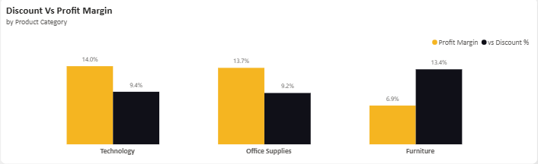
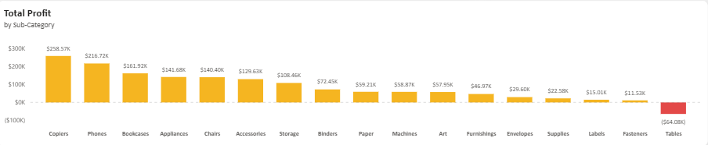

- Profitability is highly uneven by region, independent of sales volume. Southeast Asia generates $884K in sales but only a 2.0% margin (driven by a 20.9% average discount rate), while Canada despite modest sales of $66,928 posts the best margin in the business at 26.6%. The Central region drives the highest total sales ($2.82M) at a healthy 11.0% margin, making it the most reliable large market.

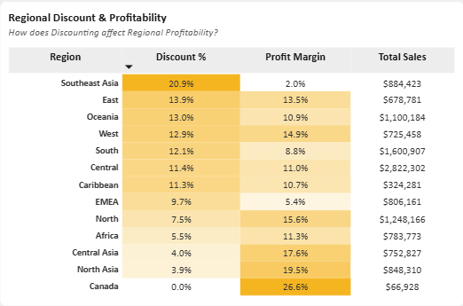
- Consumer segment dominates order volume, and the U.S. anchors global demand. Consumers account for 51.46% of orders versus 30.13% Corporate and 18.41% Home Office. At a country level, the United States alone generates 5,009 orders which is more than three times the next closest country, Australia (1,420).

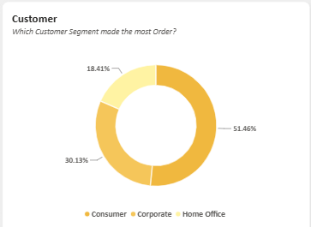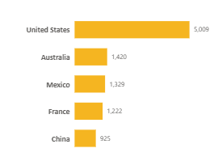

Here are some Business Risks to be considered:
- Uncontrolled discounting is eroding margins faster than sales are growing. With discount-driven losses up 50.9% year-on-year and several discount bands already deeply loss-making, continued discretionary discounting especially in Furniture and Southeast Asia threatens to offset revenue gains entirely.
- Concentration risk in loss-making product lines. Tables and other high-loss products tie up inventory and sales effort while actively destroying value; left unaddressed, this continues to drag down overall profitability.
- Regional imbalance leaves the business exposed. Heavy reliance on large but low-margin markets such as Southeast Asia and South means overall profitability is fragile, meaning that a downturn or increased competition in these markets would disproportionately hurt total profit given their already-thin margins.

There are also Business Opportunities to be taken advantage of:
- Technology and Office Supplies are high-margin growth engines. At 14.0% and 13.7% margins respectively, shifting marketing and inventory investment toward these categories; particularly Copiers (17.1% margin) and Accessories (17.3% margin) offers the fastest path to margin expansion.
- High-margin, low-discount regions can be scaled. Canada (26.6%), North Asia (19.5%), and Central Asia (17.6%) demonstrate that disciplined, low-discount markets are highly profitable; this pricing discipline can be replicated elsewhere.
- Order volume shows clear, predictable seasonality. The monthly trend line shows consistent peaks between September and November; this seasonality can be used for proactive inventory planning and targeted seasonal promotions in already-profitable categories.



Management Recommendations:
- Cap discounts at 20% company-wide, with tiered approval required above that threshold. This directly targets the $848,886 in profit currently lost to over-discounting, since margin turns negative beyond the 11-20% band.
- Review or discontinue the Tables sub-category. Given its -$64,083 loss and -8.5% margin, management should renegotiate supplier costs, reprice, or phase out underperforming Table SKUs, reallocating shelf space and catalogue focus to high-margin Technology products.
- Rebalance regional discount strategy, especially in Southeast Asia. With a 20.9% average discount driving margin down to just 2.0%, Southeast Asia should adopt the more disciplined pricing seen in Canada and Central Asia, where lower discounting sustains 17-27% margins.
- Use seasonal order trends to drive inventory and staffing planning. The clear September-November demand peak should inform proactive stock build-up and staffing ahead of Q4, minimizing stockouts in high-margin categories during the highest-order months.
- Target Home Office and Corporate segments for growth. These segments currently trail Consumer in order volume (18.4% and 30.1% respectively) but carry comparable margins (11.5-12.0%); targeted B2B and Home Office campaigns could grow volume without the margin erosion seen from Consumer-driven discounting.

Conclusion:
The Global Superstore business is growing revenue and profit at a healthy pace, but profitability is being held back by uncontrolled discounting, a structurally unprofitable Furniture sub-category, and uneven regional pricing discipline. Addressing these three areas: discount governance, product-line rationalization, and regional pricing discipline represents the clearest path to converting the company's strong sales growth into sustainably higher profit margins.

